**Computing, Year 3**

**Rich Web Applications**

**Lab sheet 2**

**Exercise 1 – XML**

1. Represent the data in the following three parts as XML documents. Paste your XML into <http://www.xmlvalidation.com/> to check if it’s well formed.

This first line in each document should be:

<?xml version="1.0" encoding="UTF-8"?>

a) The following invoice:

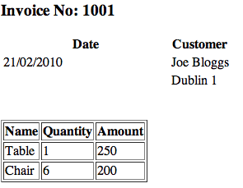

b)Create an XML document that stores details about albums, including the artist name, album name, and release date.

c) You and a friend are travelling to Rome in Italy. You are flying from Dublin to Italy on March 4th, departing from Dublin at 12.15pm and arriving in Rome at 15.25pm. You are staying for one week and leave Rome on 11th March at 16.05pm arriving in Dublin at 17.20pm. You are staying in the Radisson Hotel for 7 nights.

**Exercise 2 – JSON**

From exercise 1 above represent the 3 data parts. ie a,b,c as JSON files

**Exercise 3 AJAX Application**

Take one of the XML files from exercise one and display the details in the browser using AJAX techniques.